**pdf**

**Bluelight EU Supply Supplier Frequently Asked Questions**



For assistance, contact EU Supply (Mercell CTM)

* email: [uksupport@eu-supply.com](mailto:uksupport@eu-supply.com)
* create a Ticket through the link on your account
* phone 0800 840 2050 (office hours)

**EU Supply - Suppliers – Frequently Asked Questions (FAQs)**

*Table of Contents*

***Click ‘Ctrl’ and ‘Section title’ below to go straight to that section***

1. General 3

1.1 Which bluelight organisations (Buyers) use the bluelight EU Supply portal? 3

1.2 Is there an ‘EU Supply’ User Guide for Suppliers? 4

1.3 My question is not answered in these FAQs. Where can I get further help in relation to the system? 4

1.4 If I need to ask for further help, what information must I include in my request? 4

2. Registration /Account creation 5

2.1 How do I register as a supplier company? 5

2.2 Is registration as a supplier FREE of charge? 8

2.3 My company does not have an Organisation number, company registration number or VAT number but the on-line Registration form requests one - can we still register? 8

2.4 I tried to Register my company, but the EU Supply system advised that we are ALREADY registered. Why can’t we have more than one registration? 8

2.5 Should I have a personal email address or should we use a shared mailbox email address on our company account? 8

3. Logging On 9

3.1 I can’t remember our login details (User Name or Password). Should I register again? 9

3.2 I have forgotten my User Name and/or Password. How do I ask for a reminder? 9

3.3 I am not receiving emails from EU Supply. What can I do to resolve this? 9

3.4 I have changed my password but I still can’t log on. What can I do? 10

4. Managing your Supplier Account 11

4.1 How do I update my Personal contact details? 11

4.2 How do I update Company details? 11

4.3 I cannot edit my Company’s ‘Organisation number’ – it is greyed out. How can I change it? 11

4.4 On our Supplier account, we have one person set up as ‘Company Administrator’ and another as a ‘Company User’. What is the difference between a ‘Company Administrator’ and a ‘Company User’? 11

4.5 How do we add a new user to an existing supplier company account? 12

4.6 I think our Company account might be showing an old email address. How can I check and update contact details and email addresses? 12

5. Search for New Tender Opportunity or be Notified of New Opportunities 13

5.1 How do I Search for New Tender Opportunities? 13

5.2 How can I receive free Notifications of New Advertised tender opportunities? 13

5.3 How do I set up or change my CTM Tender Alerts? 13

5.4 I have searched and cannot find a new tender opportunity. Yet I know that my company is invited. Why can’t I find this new tender? 18

5.5 My company has several accounts. Can they be merged? 18

5.6 A buyer has asked me to provide the CTM Id number of the account that I want the tender Invitation to be sent to. What is the CTM Id and where do I find it? 18

6. Respond to Tenders 19

6.1 We have received a tender Invitation but we want to respond to it on another of our company accounts. Can we FORWARD a tender invitation to another account? 19

6.2 I want to download the tender documents but there are no documents to download/ this option does not work. How can I view or download the tender documents? 21

6.3 I have accepted a tender opportunity/ Invitation but now realise that we are not interested in this tender. What do I need to do? Can I cancel our interest? 22

6.4 I cancelled our expression of interest but now I want to undo this – we now want to be involved in this tender. Can we do this? 22

6.5 I have a question about the tender – a specific question on the commercial / financial / technical aspects of what is required (not about the system). Who do I contact? 22

6.6 What is ‘Messaging’ and how do I use it? 22

6.7 Can I submit a quotation or tender response more than once? I have already submitted my tender Response but I want to add something. 24

6.8 How do I send a screen shot (screen dump/screen grab) via email? 24

6.9 On the tender, it shows ‘Time left’. What does this mean? 25

6.10 I have attached documents in my tender Response, i.e. uploaded the compulsory documents, BUT the system still shows “1 Question unanswered”. The system does not seem to recognise that I have attached the required document.  What do I need to do to answer the question and convince the system that I have 100% completed it? 25

6.11 My colleague cannot access a tender or see the documents but I can. He has a user account on the same supplier Company account as I do. How do I allow him to access this tender? 26

6.12 How can I be sure that my tender response has been submitted? 27

6.13 What else can I do to ensure that I successfully submit my Response? 28

Response Submission Advice for Suppliers 28

1. General

### 1.1 Which bluelight organisations (Buyers) use the bluelight EU Supply portal?

**The following organisations are contracting authorities (as at 01/04/2022)**

|  |
| --- |
| Avon and Somerset Constabulary |
| Avon Fire & Rescue Service |
| 7 Force Procurement (Bedfordshire, Cambridgeshire, Hertfordshire, Norfolk, Suffolk, Kent and Essex Police ) |
| BlueLight Commercial |
| Cheshire Constabulary on behalf of Police and Crime Commissioner for Cheshire, and Cheshire Fire Authority |
| Civil Nuclear Police Authority (CNPA) / Civil Nuclear Constabulary (CNC) |
| Cleveland Fire Authority |
| Cleveland Police |
| County Durham and Darlington Fire and Rescue Service |
| Cumbria Constabulary - Office of the Police & Crime Commissioner |
| Devon and Somerset Fire and Rescue Authority |
| Dorset & Wiltshire Fire and Rescue Authority |
| Durham Police Procurement Team |
| East Sussex Fire Authority |
| Greater Manchester Combined Authority – Greater Manchester Police |
| Hereford & Worcester Fire and Rescue Service |
| Joint Procurement Service for Surrey Police and Sussex Police |
| Lancashire Constabulary |
| Leicestershire Police |
| Leicestershire Fire and Rescue Service |
| Lincolnshire Police |
| London Fire and Emergency Planning Authority / London Fire Commissioner |
| Merseyside Police |
| Mint Commercial Services LLP |
| Norfolk Constabulary and Suffolk Constabulary Procurement Unit – *now part of ‘7 Force Procurement’* |
| Nottinghamshire Police |
| Northamptonshire Police and Northamptonshire Fire & Rescue |
| North Wales Police on behalf of the Police and Crime Commissioner for North Wales |
| North Yorkshire Fire and Rescue Service |
| Northumbria Police |
| Royal Berkshire Fire and Rescue Service |
| South West Police Procurement Service (SWPPS) - Devon & Cornwall Police, Dorset Police, Gloucestershire Police, Avon & Somerset Police and Wiltshire Police |
| Staffordshire Police and Staffordshire Fire and Rescue Service |
| Thames Valley Police |
| The Police and Crime Commissioner for Derbyshire |
| Tyne and Wear Fire and Rescue Service (TWFRS) |
| Warwickshire Police |
| West Mercia Police Procurement Department |
| West Midlands Fire and Rescue Authority |
| West Midlands Police |
| Yorkshire and Humber Police Procurement (Y&HPP) - North Yorkshire Police, South Yorks Police, West Yorks Police and Humberside Police |
|  |

### 1.2 Is there an ‘EU Supply’ User Guide for Suppliers?

Yes. When you are logged into your Supplier account, on the ‘Welcome (your name)’ page - on the bottom left, click ‘Supplier tender management’ .

This will open a pdf document which is the Mercell - EU Supply – Complete Tender Management (CTM) ‘**Supplier User Guide’**.

### 1.3 My question is not answered in these FAQs. Where can I get further help in relation to the system?

For assistance, contact EU Supply (Mercell CTM)

* email: [uksupport@eu-supply.com](mailto:uksupport@eu-supply.com)
* create a Ticket through the link on your account
* phone 0800 840 2050 (office hours)

### 1.4 If I need to ask for further help, what information must I include in my request?

To help us deal with your enquiry as promptly as possible please provide the following:

https://bluelight.eu-supply.com/Media/Default/Pictures/bulletblue-1.gif Your Company Name

https://bluelight.eu-supply.com/Media/Default/Pictures/bulletblue-1.gif Name of registered account holder

https://bluelight.eu-supply.com/Media/Default/Pictures/bulletblue-1.gif Email address of user account

https://bluelight.eu-supply.com/Media/Default/Pictures/bulletblue-1.gif Name of Buying Authority (Police force/ Fire service) responsible for the Tender/Quotation

https://bluelight.eu-supply.com/Media/Default/Pictures/bulletblue-1.gif Tender Reference Number (normally 5-digits) and Tender Title

**If you do NOT provide these details, we will need to contact you to ask you**

**– delaying our response**

2. Registration /Account creation

### 2.1 How do I register as a supplier company?

To Register as a Supplier on bluelight “EU Supply” e-Tendering portal, press ‘Ctrl’ key and then click this link :- <https://bluelight.eu-supply.com>

Once on the Welcome page (“Welcome to the ‘Bluelight’ Emergency Services eTendering Site”)

on the left - in the SUPPLIER’S AREA

- click ‘**Register Company’** *(indicated by red arrow in screen shot below)*

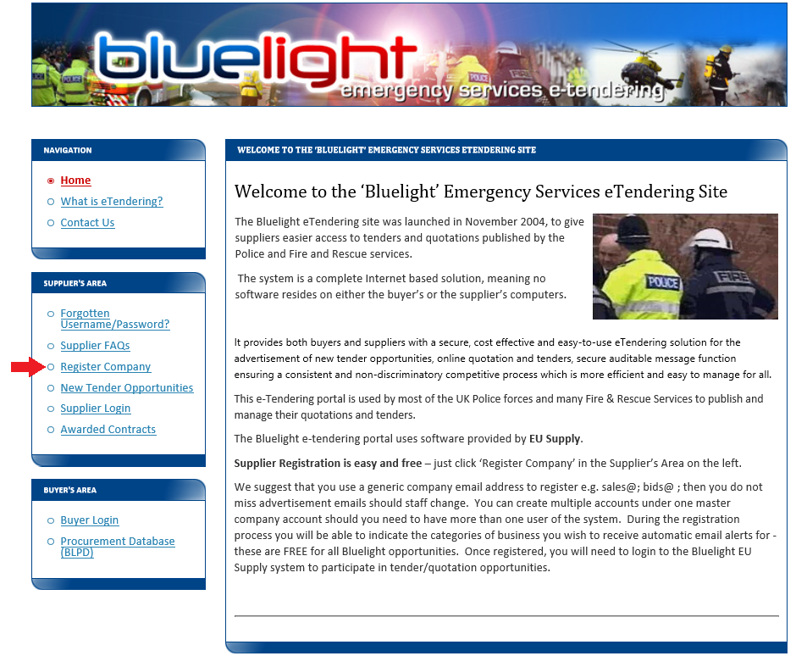

Then click **‘EU Supply – New Supplier Registration’** *(indicated by purple circle in screen shot below)*  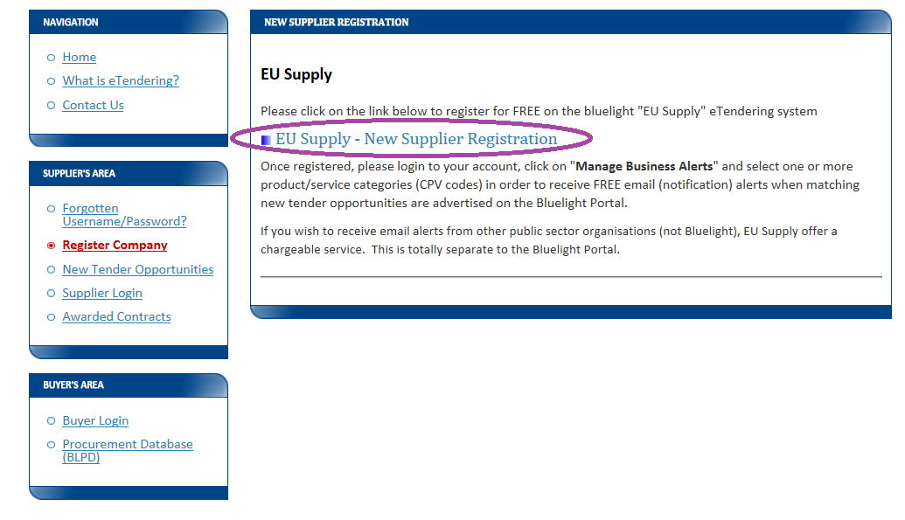

 Complete the onscreen **Supplier Registration form** and click ‘Save’ *(similar to below screen shot)*

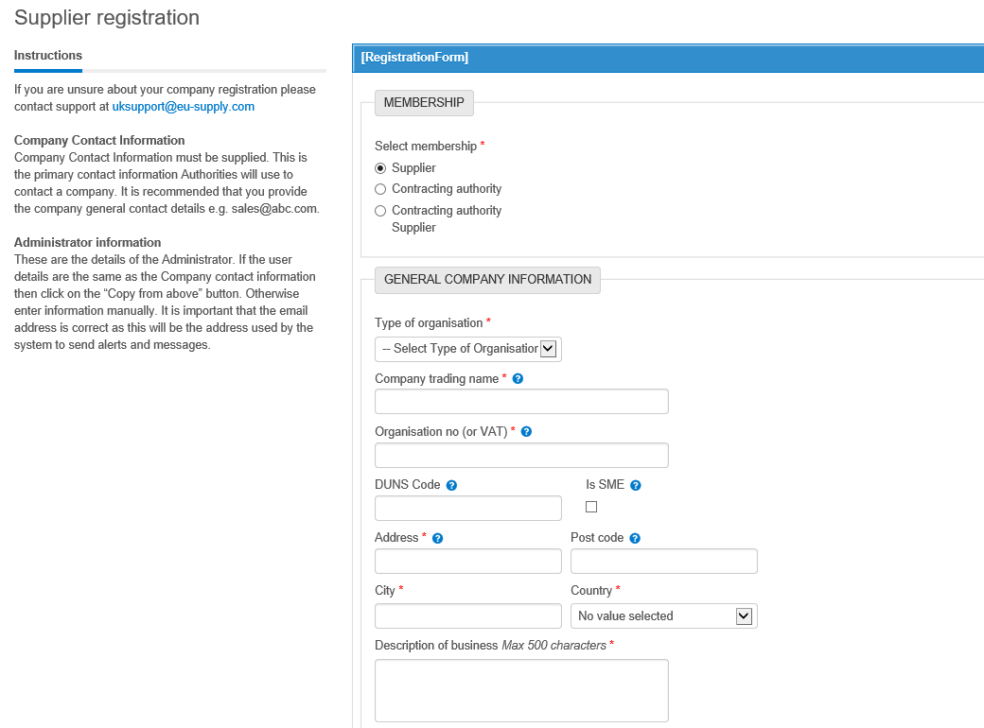

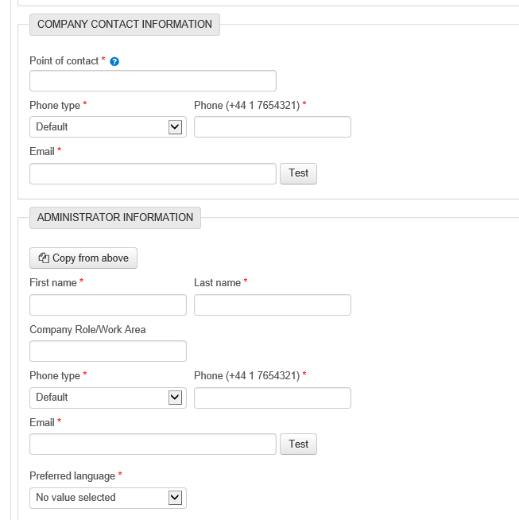

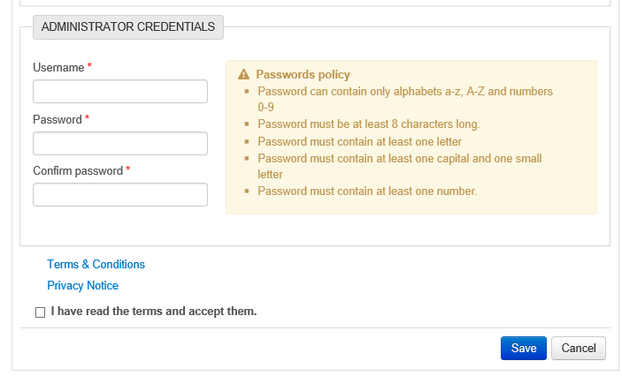

### 2.2 Is registration as a supplier FREE of charge?

Yes – on the bluelight EU Supply portal.

In addition, however, the CTM portal (Mercell) offers Supplier Premium services which are optional and do require payment of fees to EU Supply.

### 2.3 My company does not have an Organisation number, company registration number or VAT number but the on-line Registration form requests one - can we still register?

Complete your registration and input ‘n/a’ or ‘partnership’ or ‘charity’ in the relevant boxes, and submit. (The ‘Organisation number’ is the company’s number registered at Companies House).

### 2.4 I tried to Register my company, but the EU Supply system /CTM portal advised that we are ALREADY registered. Why can’t we have more than one registration?

If the EU Supply system (CTM) advises that **your company is already registered** PLEASE DO NOT register again. A supplier company should have a single account – shared with colleagues or with additional users within the same company account, if required. Having multiple supplier accounts causes confusion and can lead to missed tender invitations and notifications, as a Buyer will not know WHICH of several different accounts to send an Invitation to. It can also be very time-consuming to resolve. If you suspect you have multiple company accounts, please ask to have the unwanted accounts deactivated/closed.

### 2.5 Should I use a personal email address or should we use a shared mailbox email address on our company account?

When registering your USER, ideally that user’s registered email address should notbe someone’s personal email address. It is better to set up a user account with a shared or departmental email address/ a more ‘generic’ email address - such as [tenders@companyname.co.uk](mailto:tenders@companyname.co.uk)  or [bids@company.com](mailto:bids@company.com) - then password reset emails, notifications, etc. can be accessed when that individual person is on holiday/ away/ has left the company. NOTE:- the email address registered against a USER a/c is NOT necessarily the email address set up as the main company contact within the Company information.

3. Logging On

### **3.1 I can’t** remember our login details (User Name and/or Password). Should I register again?

NO. If you register again, it will lead to multiple accounts which cause confusion, waste everyone’s time and lead to missed tender opportunities.

### 3.2 I have forgotten my User Name and/or Password. How do I ask for a reminder?

If you have forgotten your Username and/or Password for the EU Supply portal, please go to <https://bluelight.eu-supply.com>

and in the **SUPPLIER’S AREA** on the left click on Forgotten Username/Password?

then under ‘**EU Supply’** heading, click the Forgotten username or password? link

and enter your **email address** - the one the EU-Supply system has registered for that USER and click **OK**. A reminder email will be sent to that email address. It is best to have a shared email address rather than a personal one, so that when users change, the company can still access its account.

The system sends the password reset email from [noreply@eu-supply.com](mailto:noreply@eu-supply.com) and its subject is “**Reset password**”. The ‘**Reset password’** **email *INCLUDES your Username*** - in this example screen shot of the email, the pink box indicates where your Username will be shown, and you need to click the link in blue text in the email to reset your Password.

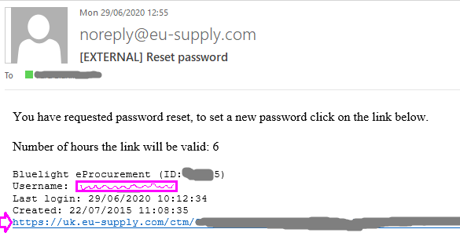

### 3.3 I am not receiving emails from EU Supply. What can I do to resolve this?

If you are not receiving emails from the EU Supply system it may be that your email firewalls or spam filters have blocked them, and dependent on your spam filter settings they may be in your junk mail box/ spam or have been automatically deleted.

Make sure that your system security /firewalls allow emails from domain name **@eu-supply.com**

### 3.4 I have changed my password but I still can’t log on. What can I do?

**Check your Username**

Your password might be correct but you might be using the **wrong Username** – be sure to check your initial ‘Reset password’ email which includes a reminder of your Username.

If you have recently changed your password, but are still unable to access your EU Supply account, it might be worth DELETING your Internet browsing history, in case your computer has remembered your old password automatically and has not picked up the fact that you have changed passwords recently. Please DELETE your internet browsing history, then log out of all internet sessions (any application that is using the Internet) and then log back in again.

Occasionally, within EU Supply you may receive the below notification:

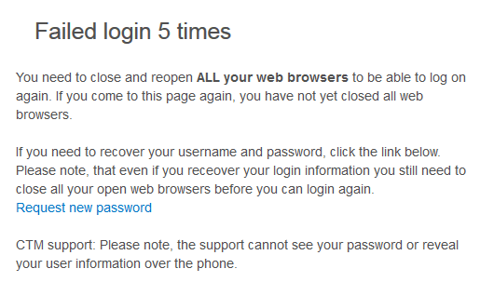

If you are using a Windows operating system, there should be a menu option within **Tools** to **Delete your internet browsing history**.  The most important thing - AFTER you have deleted your history - is to log out of **all** internet sessions for the deletion to take effect, prior to logging back in.

In addition, if you have asked your computer to remember your password each time and auto-populate the login screen, it may be worth suspending this facility, then manually entering the username and password.  You can always get your software to remember this password later - once you have been successful at logging in.

4. Managing your Supplier Account

### 4.1 How do I update my Personal contact details?

To amend your personal contact details, e-mail address, username or password

go to <https://bluelight.eu-supply.com>

click on the left hand side **Supplier Login** > and then **EU Supply – Login**

Once logged on, click your name at the top and then click ‘**Edit**’ under ‘User details’.

Edit and **Save**.

### 4.2 How do I update Company details?

To amend your company details, go to <https://bluelight.eu-supply.com>

> on the left hand side **Supplier Login** > and then **EU Supply – Login**

Once logged on, click Administration at the top > and then click “**Company administration**”.

Click ‘**Edit’** for the relevant section e.g. Company information or Supplier Profile

Note: Only users with ‘Company Administrator’ access can amend company details.

### 4.3 I cannot edit my Company’s ‘Organisation no.’ – it is greyed out. How can I change it?

This should be the number that your company is registered with at Companies House.

You cannot edit this yourself. For assistance, please contact EU Supply (Mercell CTM)

* email: [uksupport@eu-supply.com](mailto:uksupport@eu-supply.com)
* create a Ticket through the link on your account
* phone 0800 840 2050 (office hours)

### 4.4 On our Supplier account, we have one person set up as ‘Company Administrator’ and another as a ‘Company User’. What is the difference between a ‘Company Administrator’ and a ‘Company User’?

The first user to be set up on any Company account must be a Company ADMINISTRATOR. Additional users can be either Company ADMINISTRATOR or Company USER.

A **Company ADMINISTRATOR** can automatically see and submit all active tender Responses on the account - the ones he HIMSELF expressed interest in and also the ones someone else /other users on the company account expressed interest in.

A **Company USER** can submit a Response to a tender but ONLY if **he** HIMSELF has expressed interest in the tender, or he has been assigned to that tender that someone else from the account expressed interest in. He CANNOT automatically access all ongoing tenders on the account.  
If a Company USER wants to express interest in a new tender and submit a Response, then he can do this on his Company USER account, just as a Company ADMINISTRATOR would.

If a Company ADMINISTRATOR has already expressed interest in a tender, then a Company USER cannot express it again for that same tender. Instead, he has to be ‘assigned’ to that specific tender by a Company ADMINISTRATOR, so that the Company USER can access that tender and submit a Response. If a Company USER is expected to respond to any ongoing tenders on the account, a Company ADMINISTRATOR must ASSIGN the Company USER to the teams of these tenders (by going onto the Response page of a tender and clicking on ‘**Assign User Access’**, then setting the USER as an editor) and then he can access and submit them. *See also Section 6.11.*

A company account can have more than one ‘Company administrator’. A Company administrator can edit the Company details, can add and delete users and see all tenders.

### 4.5 How do we add a new user to an existing supplier company account?

If the user is replacing someone, you can EDIT the existing user’s details. It is best to regard your supplier company account as a SHARED account and not as a personal account. Simply having a shared email address and sharing logon details is the easiest way to achieve this.

If you really must add an additional user to an existing company account, go to <https://bluelight.eu-supply.com> > on the left hand side **Supplier Login** > and then **EU Supply – Login**

Once logged on, click **Administration** at the top > and then click “**User profiles**”.

Click button “**Create user…”** and fill out the form, allocating the new user with a ‘Security role’ of either “**Company administrator**” or “**Company user**” access.

Note: Only users with ‘Company Administrator’ access can add additional users to their company. *See also question 4.4 re the difference between these roles.*

Please DELETE users if they are no longer required.

### 4.6 I think our Company account might be showing an old email address. How can I check and update contact details and email addresses?

**There are TWO places within the account** where a contact NAME and EMAIL address is stored and you need to check /edit **BOTH** of these places because the Name and/or Email address may be different in the two places.

**The first place is:-**

      click “**Administration”** on the top blue row

* Click “**User profiles”**
* Click your **name** (person’s name)
* Click **EDIT** button
* and  then **edit the Name and/or** **Email address**
* and **Save**.

**The second place is:-**

       click “**Administration”** on the top blue row

* Click “**Company administration”**
* at the end of the upper section, click **Edit** button
* Under contact name and/or ‘Email address to contact person’, check this and if required, EDIT it
* and save.

Please follow the above steps to check/correct the registered Name and Email addresses.

There may be email addresses added elsewhere within the ‘Company information’ – e.g. to receive copies of emails advising of new tender Invitations.

5. Search for New Tender Opportunity or be Notified of New Opportunities

### 5.1 How do I Search for New Tender Opportunities?

New advertised tender opportunities can be found by going to <https://bluelight.eu-supply.com>

then select "**New Tender Opportunities**" from the ‘Supplier’s Area’ on the left. **This is BEFORE you log on.** This takes you to EU Supply - New Tender Opportunities – click the link. Then when you are on the screen for “Ongoing public tenders” either just select “Search“ to see all current opportunities advertised by any of the police and fire services using the EU Supply portal OR enter your search criteria (e.g. enter a word from the tender title in **keyword** box), then click **Search**.

Alternatively, if you are **already logged in to your account**, then on the Home page - ‘Welcome (your name)’ page - click top left on **CTM Published Tenders.**

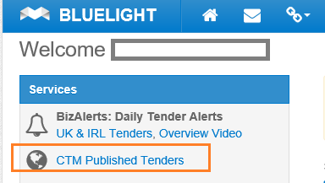

Then when you are on the screen for “**Ongoing public tenders**”, enter your search terms**.** Ensure that you change any options such as “Local” to “All”, if appropriate, by clicking down-arrows before clicking ‘Search’ button. The advertised Public Quotes/Tenders (i.e. your search results) will be listed underneath. Click on the blue text of the tender Name to access the advertised opportunity. You will not be able to read or download tender documents until after you have expressed an interest in the opportunity- click ‘Accept’ button in top left corner.

If you have added one or more CPV codes/category codes to your account and have set up your **CTM Tender Alerts** (see below question), you will receive free automatic email notifications when new tender opportunities are advertised by the authorities using the portal under the categories /CPV codes you have selected. This reduces the need to regularly search for new advertised opportunities that may be of interest to you.

### 5.2 How can I receive free Notifications of New Advertised tender opportunities?

EU Supply asks you to set up certain ‘**Category Codes’** (Common Procurement Vocabulary or **CPV codes)** to describe what kinds of business / service you provide.

This is a fundamental part of your management of your supplier account. It is important to set these up on your account because they can impact whether a buyer might select your company to Invite, based on the CPV Codes you have set up.

If you also set up ‘**Manage CTM Tender Alerts’,** you will receive free automated emails notifying you of all Advertised new tender opportunities that match your CPV Codes. This will save you from having to search for new tender opportunities on a regular basis. *See 5.3 below.*

### 5.3 How do I set up or change my CTM Tender Alerts?

To do this go to <https://bluelight.eu-supply.com> click **Supplier Login** and then EU Supply – Login and enter your username and password.

Once logged on, the “**Manage CTM Tender Alerts**” option is within the Services area on the left hand side of your Welcome … page.

‘CTM Tender Alerts’ used to be called ‘Business Alerts’ and are free. (Note BizAlerts are NOT free)

Please note that you will only be automatically alerted of a matching ADVERTISED new tender opportunity. If the tender is being run by direct INVITATION (not advertised), only those suppliers who have been sent an Invitation will receive a notification.

Alternatively, you can find **CTM Tender Alerts** via “**Administration**” on the top blue header

>> **Company administration** >> scroll down to the bottom

>> **Manage CTM Tender Alerts** >> Edit

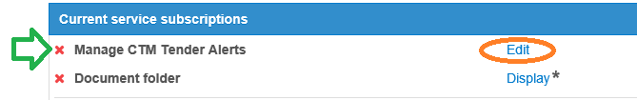

**Setting up “CTM Tender Alerts” is a 2-part process**

1. firstly you need to select that you want to receive alerts
2. secondly select Category Codes (CPV codes) that match your business

Firstly, the ‘Company Administrator’ of the account clicks ‘**Manage CTM Tender Alerts’**

Then click the button **Start using CTM Tender Alerts** *(circled in orange in screen shot below)*

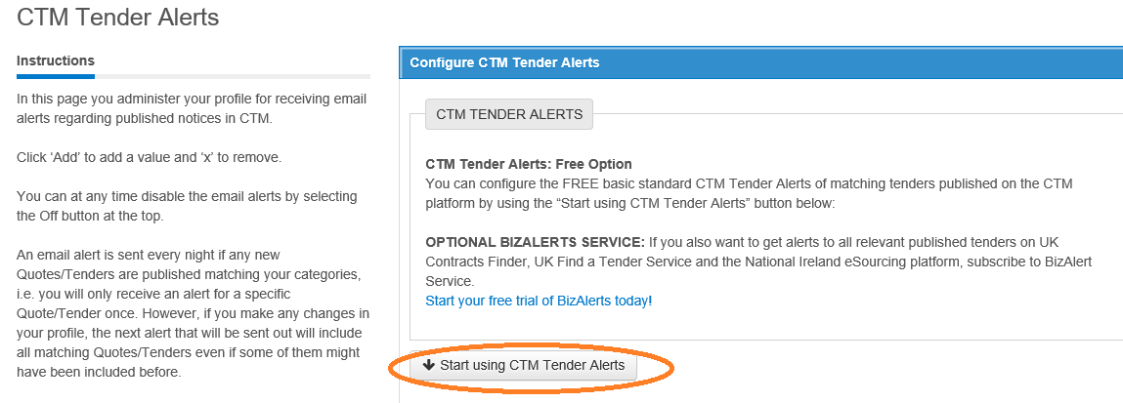

Make sure you have at least one email address in the box next to **Add email**  and **Save.**

Then click **Next** button.

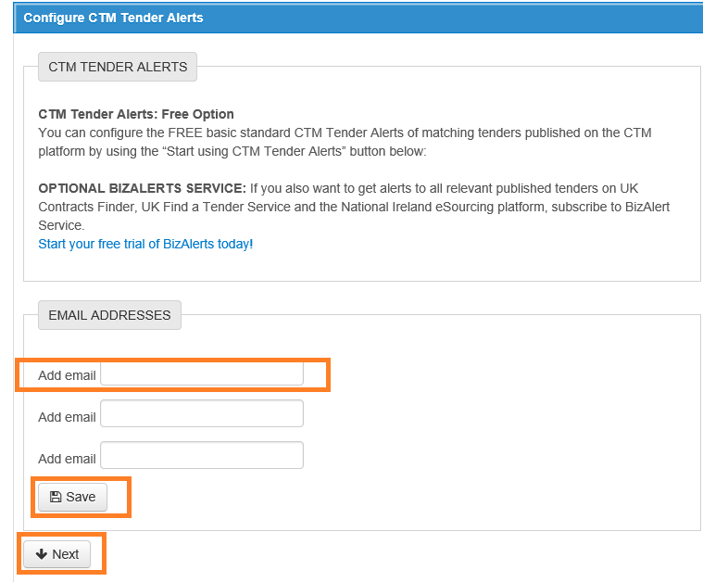

Then click **+ ADD CPV codes** - to select the Category Codes / CPV codes that match your business, so that you will receive notifications only about new tenders that are relevant to your business.

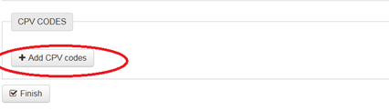

You then need to find and select CPV codes that best match your business - you can either use the **Search** facility or click in the **CPV tree** of codes.

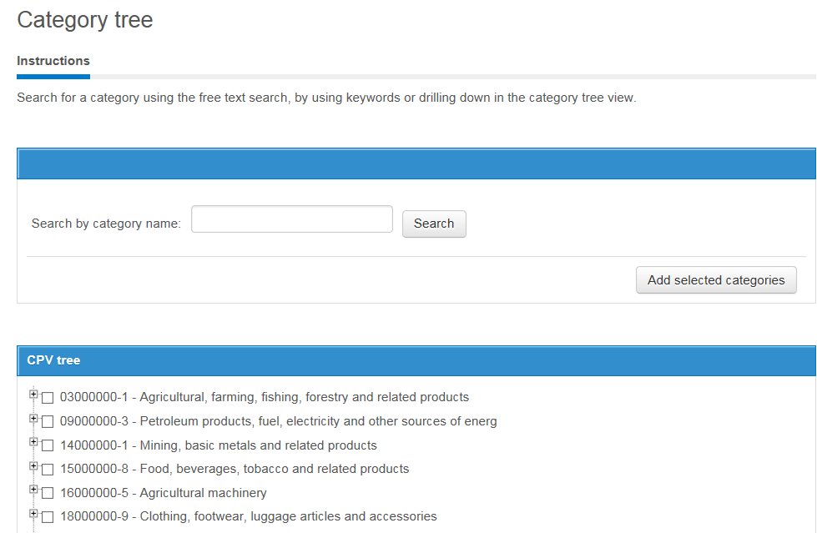

If you **click the little + sign** to the left of the code, it reveals lower / more specific codes.

e.g. Agricultural machinery 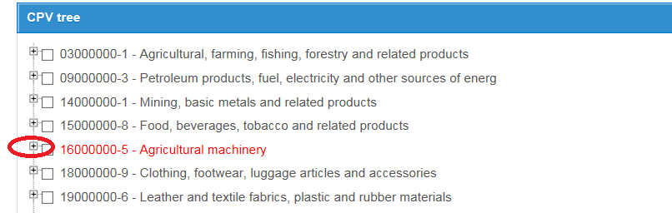

Clicking the **+ sign** then reveals:- 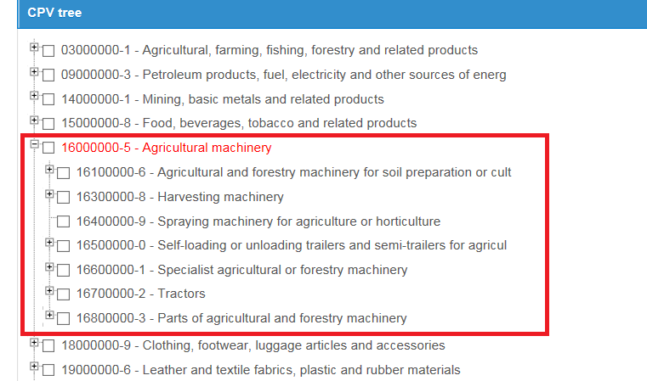

If you really need to be specific, you can again click the **+** sign to the left of the box and see further detailed codes.

When you find the code or codes you want, click / **tick the little box** (to show which ones you want to select)

and then click the button **“Add selected categories**” 

Then click **“Finish**” button and **“Done”** button.

N.B. If you select a high level code (broad code) and also several lower level codes (more specific) the system will choose just the high level one.

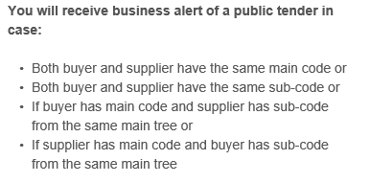

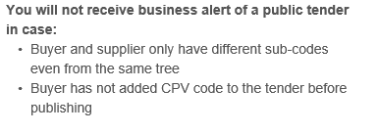

### 5.4 I have searched and cannot find a new tender opportunity. Yet I know that my company is invited. Why can’t I find this new tender?

Some tenders are not advertised/ not published/ not publicly viewable or searchable. This is because the tender is being run via **Invitation**. In this case, a buyer sends Invitations directly to a number of Supplier accounts and you will need to log into a particular INVITED account in order to see and accept the Invitation.

If you know that your company has been Invited and you are logged into your account and cannot see the Invitation there, then the Invitation has been sent to a different account. This can easily happen when your company has MULTIPLE accounts. Having duplicate/ multiple accounts causes confusion, wastes everyone’s time and leads to missed tender opportunities. Please try to REDUCE the number of different accounts to a MINIMUM.

### 5.5 On my company account, do I need to select CPV Codes/ Products and Services offered?

Yes. In your Company Information, within “Supplier profile”, there is a section for you to list the Products / Services that you offer. Click the Add button to choose the categories that you offer. A buyer may use these to search for relevant suppliers and if you have left them blank, you may miss out on an opportunity.

### 5.6 My company has several accounts. Can they be merged?

No. Supplier accounts cannot be merged. But they can be edited and they can be closed or deactivated.

If your company has duplicate/multiple accounts, please confer with your colleagues to decide which accounts can be deactivated. Try to reduce your company accounts to ONE. If your company MUST have several different accounts, try to differentiate them – maybe add a location or a sector after the company name. Or add the words MAIN ACCOUNT after the name of the company on the account you wish to mainly use. This will assist a buyer to identify which account of your several separate accounts to send a tender Invitation to.

### 5.7 A buyer has asked me to provide the CTM Id number of the account that I want a tender Invitation to be sent to. What is the CTM Id (Unit ID) and where do I find it?

CTM is the name of the EU Supply e-tendering portal - “**C**omplete **T**ender **M**anagement”.

Each supplier company account has a unique identifying number – the CTM Id. Even if the company name, individual’s name and email address are the same or near-identical on different accounts, the CTM Id number is unique to a particular company account.

To find your company’s **CTM Id**, click on **Administration** (top blue line) and then down to “Company administration”. You need to have ’Company administrator’ access to be able to do this. The CTM Id number is within your Company information, on the right just above the Company description. It is usually a 5-digit number but can be only 3 or 4 digits on old accounts. In example screen shot below, **the CTM Id** is indicated with the lower green circle.

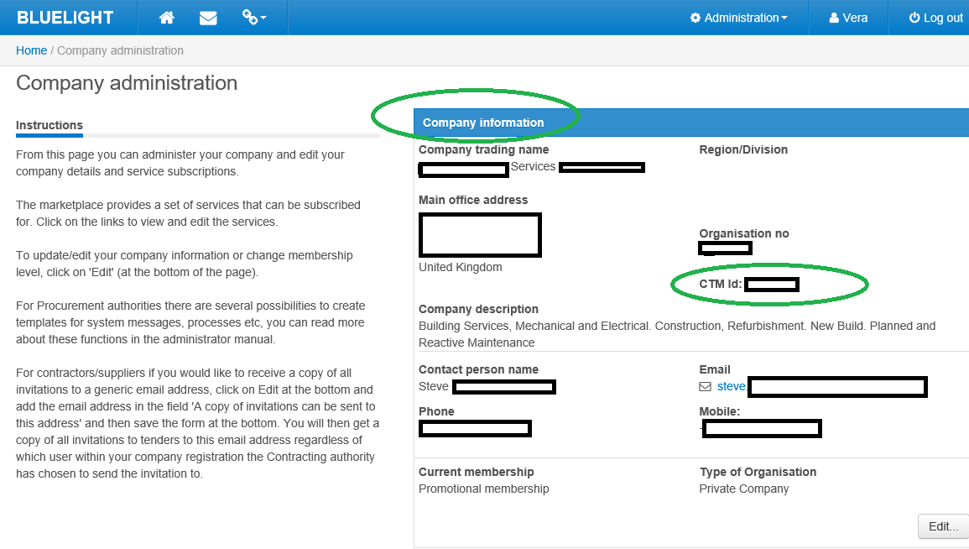

6. Respond to Tenders

### 6.1 We have received a tender Invitation but we want to respond to it on another of our company accounts. Can we FORWARD a tender invitation to another account?

**To Forward an Invitation on the portal:-**

Never accept an Invitation on an account that you do not wish to use to RESPOND to that tender. You can FORWARD an Invitation from one account to another – but ONLY provided that the Invitation has NOT been accepted. The MOST important thing is NOT to Accept it first because this will make it IMPOSSIBLE to forward to another account. Also, you can only forward to another account that is using the same email domain name – the words after the @ must be the same on both accounts.

**How to Forward the unaccepted Invitation on your Welcome page** 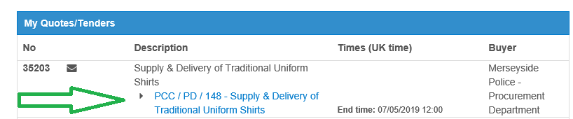

**Find the unaccepted Invitation** (black closed envelope icon indicates it has not been accepted) **> Click on the tender Title** (in blue writing)

**DO NOT ‘Accept’ it** - instead click the **‘Forward…’** button *(indicated by orange arrow in screenshot below)*



You will then see a list of the alternative company accounts to choose from / to Forward the invitation to

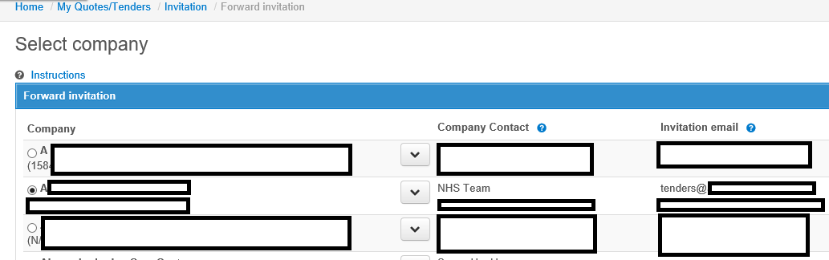

**Select which account to forward to**

* Click on the little CIRCLE to the LEFT of the Company (to choose it)
* then click the drop-down ARROW to select the individual within that company account
* Tick the little square to the left of the individual user or users you wish to FORWARD the Invitation to
* and then **click the ‘Forward’ button** in the bottom right of the *screen (indicated with green circle in screen shot below)*

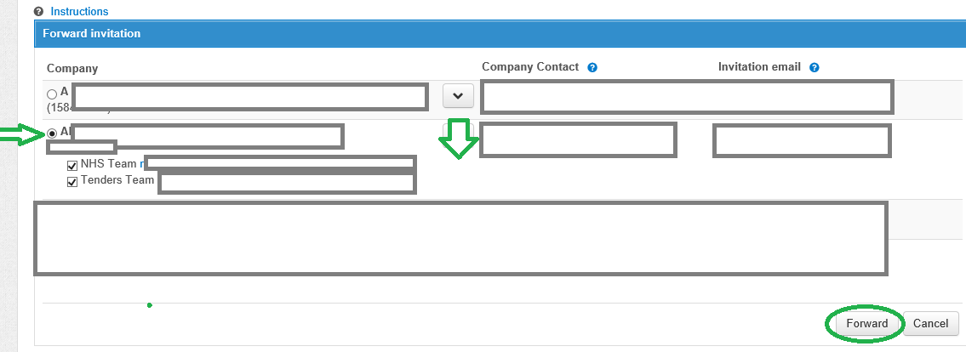

You are asked to **Confirm Forward** - click ‘Yes’ button

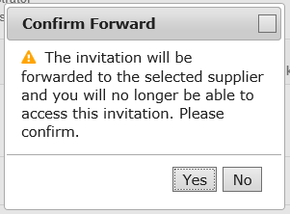

**Confirmation should appear…**

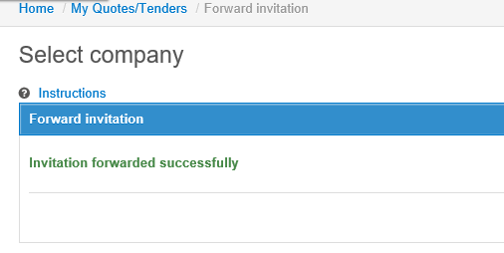

### 6.2 I want to download the tender documents but there are no documents to download/ this option does not work. How can I view or download the tender documents?

FIRST you need to express your interest in the tender – click the big blue **Accept** button - top left on the screen. Or if you have been Invited, you need to open and Accept the Invitation. Then you will be able to view and download the tender documents.

When you are logged on and IN the particular Tender, within the **My Response** tab - click the option “**Access documents**” *(circled red in screen shot below)* to view and download the documents provided by the buyer.

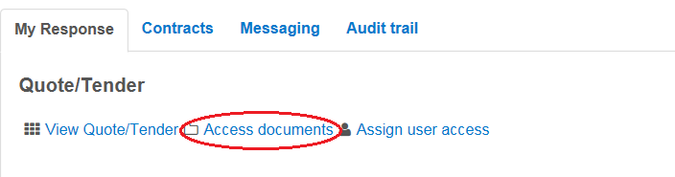

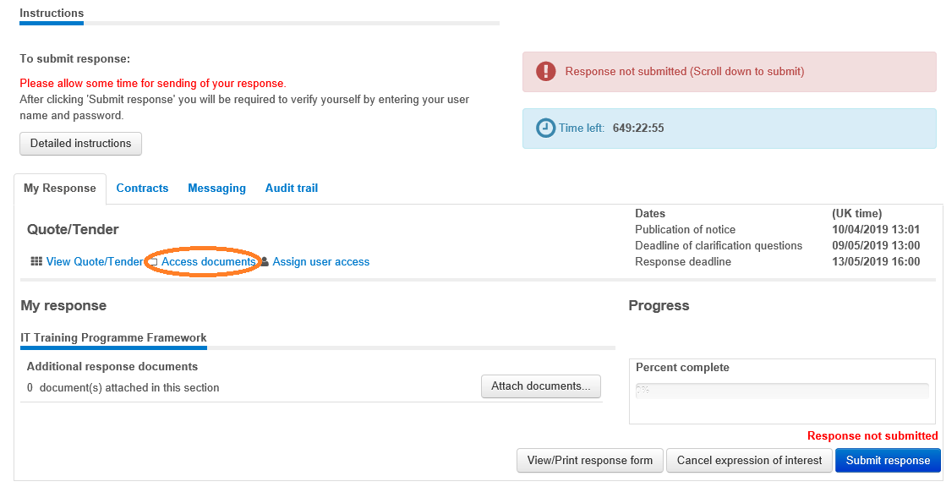

### 6.3 I have accepted a tender opportunity/ Invitation but I now realise that we are not interested in this tender. What do I need to do? Can I cancel our interest?

Click the ‘**Cancel expression of interest’** button at the bottom of the tender response page (on the ‘My Response’ tab)



### 6.4 I cancelled our expression of interest but now I want to undo this – we now want to be involved in this tender. Can we do this?

Yes. If you can see the **‘Resume’** button, click this and you will resume your interest in the tender.

### 6.5 I have a question about the tender – a specific question on the commercial / financial / technical aspects of what is required (not about the system). Who do I contact?

You should NOT email the buyer. You need to contact the Buyer responsible for the particular Tender/Quote and you do this within the portal via the **Messaging** function within the tender.

### 6.6 What is ‘Messaging’ and how do I use it?

Within each Tender, there is a tab called Messaging. The ‘**Messaging’** function is like an internal email system on the portal - between the Buyer and the Suppliers on THIS particular tender. It keeps all questions and their answers on the Tender and ON the system, so is auditable.

The Buyer can send you a Message and you can send the Buyer a New Message or reply to the Buyer. System confirmations also appear in Messaging.

**To send a new ‘Message’…**

(1)    Log into your bluelight ‘EU Supply’ supplier account

(2)    then under ‘**My Quotes/Tender’**, click into the particular Tender  - *the blue writing/the title*

(3)    Then **within the tender**, click on the ‘**Messaging**’ tab

 - *circled in green in the example screen shot below*

       – to create a “New Message”,  click on “**New message**…“ button

     >  then type in your question

     > you do not need to choose a Recipient as it will ONLY go to the Buyer

     >  then **Send**

      – it will go directly to the Buyer, who will then answer – ALSO within the Tender, so you need to go into the Tender later to see what the answer is.

Example screen shot:-  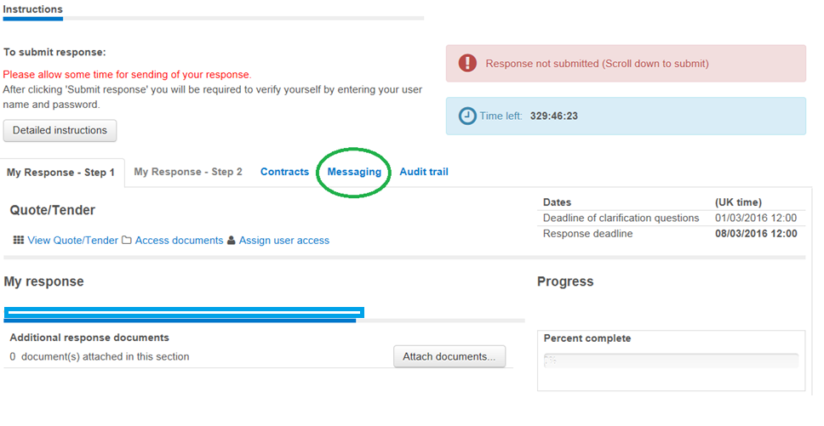

A Message in **bold** type has NOT been read by you / is still unread by you.

A Message shaded in pink has not yet been sent by you – it is still in DRAFT status. You need to send it.

### 6.7 Can I submit a quotation or tender response more than once? I have already submitted my tender Response but I want to add something.

As long as the ‘Submit response’ button is still blue, you can still submit a Response 

If this button is greyed out, you are locked out of the tender and cannot submit a Response.

When the response deadline is reached, time has run out and the ‘Submit response’ button turns from blue to grey. At this point the accounts of all the suppliers involved in the tender are automatically locked, allowing no further response activity on the tender.

You can submit a quotation /tender response as many times as you want, until the ETQ (End Time Quotation) has timed out – i.e. until the response deadline is reached. Later submissions will overwrite earlier ones, so the Buyer will only see your latest submission /last Response submission. The Buyer cannot see your Response submission until the ETQ has timed out. It is better to submit early and update information, rather than leave the whole submission until the last minute. **Make sure** you answer all questions and attach all response documents **BEFORE** clicking the ‘Submit response’ button.

**Do not click the “Withdraw response” button** *(indicated with red circle below).* This button can be misleading – it does NOT withdraw an already-submitted response but **withdraws the supplier completely from the tender.** If a Supplier clicks “Withdraw response” it means that they are no longer able to participate in this tender – they have removed themselves from it.

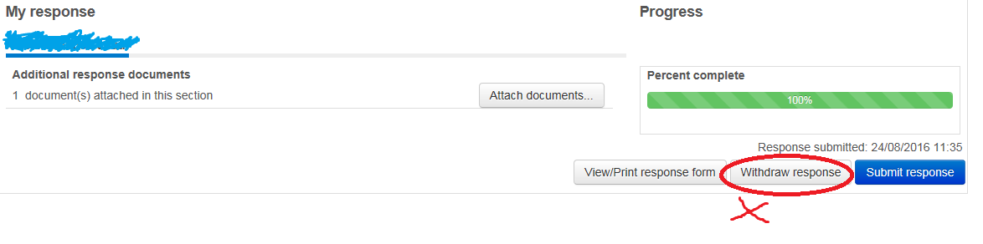

### 6.8 How do I send a screen shot (screen dump/screen grab) via email?

If you want to illustrate what you are seeing on your screen (such as an error or warning), you might want to send a Screen shot.

To take the screen shot, click on the relevant screen and click the ‘Alt’ key and the ‘Print Screen’ key. This copies the screen. Then to paste the screen copy – into an email or a Word document - open the correct place in the email or Word document and press the keys ‘Ctrl’ & ‘V’. This pastes the image into the email or document.

### **6.9 On the tender, it shows** ‘Time left’. **What does this mean?**

The ‘Time left‘ is a Live countdown of how much time you have left until the Response deadline.

For example:- 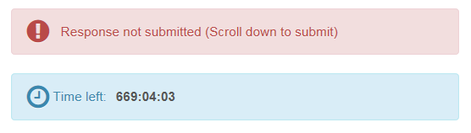

In the above example, the time left is 669:04:03. This is 669 Hours, and 4 Minutes and 3 seconds.

**Allow PLENTY of time for uploading and submitting your response.**

**At the end of your response you will be asked to CONFIRM your User Name and Password so have them handy and allow time to confirm them**. This needs to be BEFORE the deadline. If you cannot see the Pop-up where you confirm your Username and Password, Minimise your window – the window you need might be behind.

It is an electronic deadline so you will be locked out of the tender before you have finished if you do not allow sufficient time. Do not start to upload your attachments just a few minutes before the response deadline - you will be timed out and your efforts will have been for nothing. Allow PLENTY of time. **Late responses are NOT accepted.**

### **6.10 I have attached documents in my tender Response, i.e. uploaded the compulsory documents, BUT the system still shows** “1 Question unanswered”. **The system does not seem to recognise that I have attached the required document.  What do I need to do to answer the question and convince the system that I have 100% completed it?**

Check that you have attached required attachments WITHIN any online questionnaire – check for a red file icon. If you have a "free text box" within the question as well, in order to get the question 100% answered, a supplier needs to ALSO type something into this blank free text box (as well as uploading the file/adding the required attachment). i.e. you need to BOTH **type something** into the blank “free text box” **AND upload** your attachment. Otherwise the system won't understand that you HAVE 100% answered that question.

Example: Official Secrets Act question:-  
Supplier has attached the required file (this part is OK) but the "free text box" is still empty. You can just type there **"File attached"** or **"Document added"** and Save.   
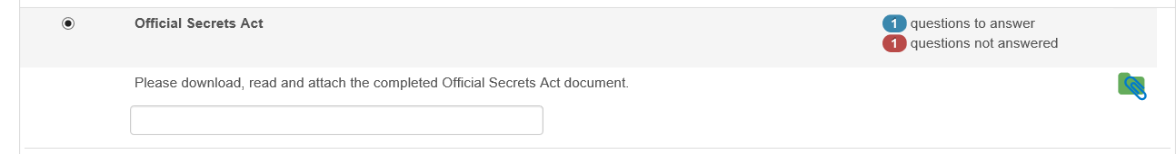

6.11 My colleague cannot access a tender or see the documents but I can. She has a user account on the same supplier Company account as I do. How do I allow her to access this tender?

When you are logged on and IN the particular Tender, within the **My Response** tab - click the option “**Assign user access**” *(circled in orange in screen shot below)*

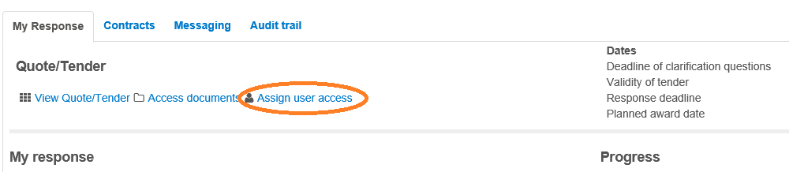

Then click the “**Add/Remove members…”**  button -*(circled in orange in screenshot below)*

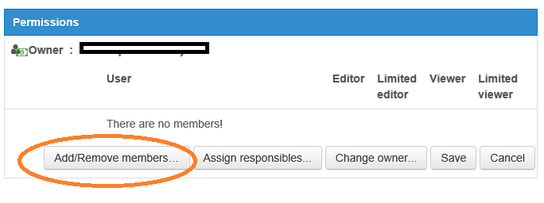

>> you should then see a list of users. From the list of users (other users on this company account) listed in the left hand box, select your colleague (one or more user)

>> then click the right pointing arrow **->** to move your colleague from the left-hand box to the right-hand box (i.e. to add them to this tender team)

>> then click the “**Assign responsibilities…”** button -  to assign her a Responsibility level – ‘ **Editor**’ will allow her to do most things on the tender. You must assign one responsibility, otherwise she will have no ability to do anything on this tender. You will need to do this for EACH tender you want your colleague to work on.

6.12 How can I be sure that my tender response has been submitted?

When you are in the particular Tender, within the **My Response** tab – complete all your questions and attach all required attachments. Then click the **big blue button** in the bottom right corner “**Submit response…**” *(circled in green in screen shot below)*

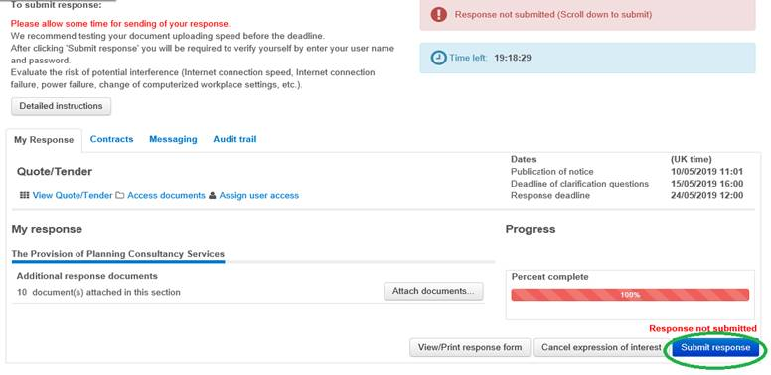

After you have clicked the “**Submit response”** button – once and firmly - you will be asked to confirm your User Name and Password. You must do this successfully.

Then the box showing the “**100%”** in the ‘**Percent complete**’ field should turn from red shading to **green shading.** Wait a few minutes for the response to register.

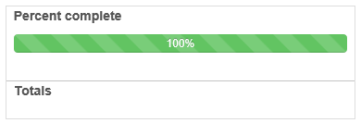

**If the background shading of the 100% box stays red, you have not successfully submitted your tender response.**

On your response screen, there will also be red reminders saying “**Response not submitted**”. This means that you have NOT yet successfully submitted your tender response**.** Wait a while and if it still does not change, try again. **Try Minimising your window** to reveal the screen behind - the screen you need may be open but BEHIND your front screen.

Allow plenty of time. If it still does not successfully submit, try closing all internet browser sessions and try again. You could also try shutting down your computer or using a different Internet Browser. See also section 6.13.

When you have successfully submitted your response, at the top of your screen you will see a message in a green-shaded box “**Response submitted**: …and the date and time of submission. *(see screenshot below)*

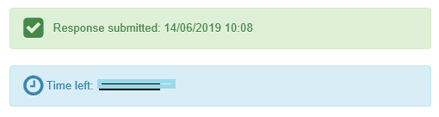

and at the bottom of your screen it will also state “Response submitted: and the date and time submitted. This is just above the big “Submit response…” button.

You should also receive a System message (on “Messaging” tab) confirming successful submission.

6.13 What else can I do to ensure that I successfully SUBMIT my Response?

Tender Response Submission Advice for Suppliers

**Allow plenty of time**

You should **start to upload** your tender response **the day before the tender Response deadline**

and at least **4 working hours before** the deadline. Then if you do encounter a problem, you should have time to resolve it.

**If you do encounter a problem, please contact EU Supply (Mercell CTM)**

* email: [uksupport@eu-supply.com](mailto:uksupport@eu-supply.com)
* create a Ticket through the link on your account
* phone 0800 840 2050 (office hours)

at least 2-3 working hours before the deadline to allow them to help you.

If you try to upload a dozen documents and submit your response within the last 10 minutes before the deadline, you unnecessarily increase your chances of being locked out of the tender before you have submitted.

**Be sure of your User Name and Password**

Make sure that you know and have successfully used your User Name and Password. After you have

clicked the ‘Submit Response’ button, the system will present you with a Pop-up (small window) asking you to confirm your User Name and Password and this must be successfully completed before the deadline. This pop-up might open in the window BEHIND the one you are looking at - ‘minimise’ your window to check if what you need is behind.

**Check your internet browser settings + Minimise your main/front window**

Regardless of which browser you use, your browser’s settings must allow Pop-ups. Check if you have browser settings that block Pop-ups or always open them in the background. Either change these settings, or check your background windows if you suspect that your response submission has not completed successfully. Make sure that you click the “Submit Response” button firmly once and not repeatedly.

By default, the pop-up window opens in front but if you click the “Submit response” button several times, the Pop-up window goes into the background and you may need to Minimise your main window/ the front window, so that you can see the other windows behind. This also can apply if you are completing a tender on-line questionnaire and a clicked option (such as a table or option to attach an attachment) seems not to open – ‘Minimise’ your window so that you can see the window that is open behind.

**Don’t submit your tender response using a mobile phone/smart phone**

The EU Supply system is not designed fully for mobile use.

**Allow time for large files to upload**

Large files can slow things up. The recommended maximum upload file size is 2.14 GB. Uploading huge files or large numbers of files takes time and you need to allow for this when attaching files.

**Ensure that only one user uploads documents at any one time and submits your response**

If you have more than one user on the same supplier company account, ensure that they are not uploading documents at the same time from different computers and even from the same Username, as the system may not tolerate this and uploads might not be successful.

**Use a computer that has adequate speed and use a good internet connection**

Check that your network connection and stability is good. If your internet connection ‘comes and goes’ then you might not get your files uploaded on time, especially if you are also using an old slow computer.

**Delete your internet browsing history, delete cookies and close down all browser sessions. Then log on and try submitting again**

If you have left the page open without doing anything for some time, then logging out and back in should help but of course if you realise too late that you have not completed your response submission then you still might run out of time. Deleting browsing history and cookies and closing down all browser sessions is especially relevant if you had to request a password reset.

**Ensure user who submits your response is set up to ‘sign on behalf of the company’**

If, when you submit your response, you see a warning that you are not able to sign on behalf of your company, then your Company Admin needs to check the ‘User settings’ within that user’s personal profile. The user who is Submitting the response must be ticked as a company signer:-

cid:jira-generated-image-static-868eb5a0-733c-4808-8e03-7ecb0b8f85a9

**Contact EU Supply /Mercell CTM**

If you encounter a problem or suspect that something is preventing your tender response submission from registering…

**do not call the buyer**

**instead please contact EU Supply (Mercell CTM)**

* email: [uksupport@eu-supply.com](mailto:uksupport@eu-supply.com)
* create a Ticket through the link on your account
* phone 0800 840 2050 (office hours)

at least 2-3 working hours before the deadline to allow them to help you.

Please allow time for EU Supply/Mercell CTM to respond to your request for help.

~~~Bluelight ~~Bluelight ~~Bluelight ~~Bluelight.~~Bluelight.~~Bluelight~~Bluelight~~~