**Bluelight EU Supply Supplier Frequently Asked Questions**



**Bluelight Procurement Admin email: BLAdmin@cheshire.pnn.police.uk**

**EU Supply - Suppliers – Frequently Asked Questions (FAQs)**

Table of Contents

1.General 3

1.1 Which bluelight organisations (Buyers) use the bluelight EU Supply portal? 3

1.2 Is there an ‘EU Supply’ User Guide for Suppliers? 4

1.3 My question is not answered in these FAQs. Where can I get further help in relation to the system? 4

1.4 If I need to ask for further help, what information must I include in my request? 4

2. Registration /Account creation 5

2.1 How do I register as a supplier company? 5

2.2 Is registration as a supplier FREE of charge? 8

2.3 My company does not have an Organisation number, company registration number or VAT number but the on-line Registration form requests one - can we still register? 8

2.4 I tried to Register my company, but the EU Supply system advised that we are ALREADY registered. Why can’t we have more than one registration? 8

2.5 Should I have a personal email address or should we use a shared mailbox email address on our company account? 8

3.Logging On 9

3.1 I can’t remember our login details (User Name or Password). Should I register again? 9

3.2 I have forgotten my User Name and/or Password. How do I ask for a reminder? 9

3.3 I am not receiving emails from the EU Supply system. What can I do to resolve this? 9

3.4 I have changed my password but I still can’t log on. What can I do? 9

4. Managing your Supplier Account 11

4.1 How do I update my Personal contact details? 11

4.2 How do I update Company details? 11

4.3 I cannot edit my Company’s ‘Organisation number’ – it is greyed out. How can I change it? 11

4.4 On our Supplier account, we have one person set up as ‘Company Administrator’ and another as a ‘Company User’. What is the difference between a ‘Company Administrator’ and a ‘Company User’? 11

4.5 How do we add a new user to an existing supplier company account? 12

4.6 I think our Company account might be showing an old email address. How can I check and update contact details and email addresses? 12

5. Search for New Tender Opportunity or be Notified of New Opportunities 13

5.1 How do I Search for New Tender Opportunities? 13

5.2 How can I receive free Notifications of New advertised tender opportunities? 13

5.3 How do I set up or manage my Business Alerts? 13

5.4 I have searched and cannot find a new tender opportunity. Yet I know that my company is invited. Why can’t I find this new tender? 17

5.5 My company has several accounts. Can they be merged? 18

6. Respond to Tenders 19

6.1 I want to download the tender documents but there are no documents to download/ this option does not work. How can I view or download the tender documents? 19

6.2 I have accepted a tender opportunity but now realise that we are not interested in this tender. What do I need to do? Can I cancel our interest? 19

6.3 I cancelled our expression of interest but now I want to undo this – we now want to be involved in this tender. Can we do this? 19

6.4 I have a question about the tender – a specific question on the commercial / financial / technical aspects of what is required (not about the system). Who do I contact? 19

6.5 What is ‘Messaging’ and how do I use it? 19

6.6 Can I submit a quotation or tender response more than once? I have already submitted my tender Response but I want to add something. 21

6.7 How do I send a screen shot (screen dump) via email? 21

6.8 On the tender, it shows ‘Time left’. What does this mean? 22

6.9 I have attached documents in my tender Response, i.e. uploaded the compulsory documents, BUT the system still shows “1 Question unanswered”. The system does not seem to recognise that I have attached the required document.  What do I need to do to answer the question and convince the system that I have 100% completed it? 22

1.General

### 1.1 Which bluelight organisations (Buyers) use the bluelight EU Supply portal?

**The following organisations are contracting authorities (as at 26/07/2017)**

|  |
| --- |
| Avon and Somerset Constabulary |
| Avon Fire & Rescue Service |
| BCH Procurement (Police and Crime Commissioners for Bedfordshire, Cambridgeshire and Hertfordshire ) |
| Bedfordshire Fire and Rescue Service |
| Cheshire Constabulary on behalf of the Police and Crime Commissioner for Cheshire |
| Civil Nuclear Police Authority (CNPA) / Civil Nuclear Constabulary (CNC) |
| Cleveland Police |
| County Durham and Darlington Fire and Rescue Service |
| Cumbria Constabulary - Office of the Police & Crime Commissioner |
| Devon and Somerset Fire and Rescue Authority |
| Dorset & Wiltshire Fire and Rescue Authority |
| Durham Police Procurement Team |
| East Midlands Strategic Commercial Unit (EMSCU) - Nottinghamshire Police and Northamptonshire Police |
| East Sussex Fire Authority |
| Greater Manchester Combined Authority – Greater Manchester Police |
| Hereford & Worcester Fire and Rescue Service |
| Joint Procurement Service for Surrey Police and Sussex Police |
| Lancashire Constabulary |
| Leicestershire Police |
| Leicestershire Fire and Rescue Service |
| London Fire and Emergency Planning Authority |
| Merseyside Police |
| Metropolitan Police Service |
| Norfolk Constabulary and Suffolk Constabulary Procurement Unit |
| North Wales Police on behalf of the Police and Crime Commissioner for North Wales |
| Northumbria Police |
| South West Police Procurement Department (SWPPD) - Devon & Cornwall Police, Dorset Police, Gloucestershire Police and Wiltshire Police |
| Staffordshire Fire and Rescue Service |
| Staffordshire Police |
| Thames Valley Police |
| The Consortium |
| The Police & Crime Commissioner for Lincolnshire |
| The Police and Crime Commissioner for Derbyshire |
| Tyne and Wear Fire and Rescue Service (TWFRS) |
| Warwickshire Police & West Mercia Police Procurement & Contracts Department |
| West Midlands Fire and Rescue Authority |
| West Midlands Police |
| Yorkshire and Humber Police Procurement (Y&HPP) - North Yorks Police, South Yorks Police, West Yorks Police and Humberside Police |

### 1.2 Is there an ‘EU Supply’ User Guide for Suppliers?

Yes. When you are logged into your Supplier account, on the ‘Welcome (your name)’ page - on the bottom left, click ‘Supplier tender management’ . This will open a document which is the EU Supply – Complete Tender Management (CTM) ‘**Supplier User Guide’**.

### 1.3 My question is not answered in these FAQs. Where can I get further help in relation to the system?

Please email Bluelight eTendering Administration atemail: [BLAdmin@cheshire.pnn.police.uk](mailto:BLAdmin@cheshire.pnn.police.uk)

### 1.4 If I need to ask for further help, what information must I include in my request?

To help us deal with your enquiry as promptly as possible please provide the following:

https://bluelight.eu-supply.com/Media/Default/Pictures/bulletblue-1.gif Your Company Name

https://bluelight.eu-supply.com/Media/Default/Pictures/bulletblue-1.gif Name of registered account holder

https://bluelight.eu-supply.com/Media/Default/Pictures/bulletblue-1.gif Name of Buying Authority (Police force/ Fire service) responsible for the Tender/Quotation

https://bluelight.eu-supply.com/Media/Default/Pictures/bulletblue-1.gif Tender/Quotation Reference Number and Title

2. Registration /Account creation

### 2.1 How do I register as a supplier company?

To Register as a Supplier on bluelight “EU Supply” e-Tendering portal, press ‘Ctrl’ key and then click this link :- <https://bluelight.eu-supply.com>

Once on the Welcome page (“Welcome to the ‘Bluelight’ Emergency Services eTendering Site”)

on the left - in the SUPPLIER’S AREA - click ‘**Register Company’***(indicated by red arrow in screen shot below)* ** 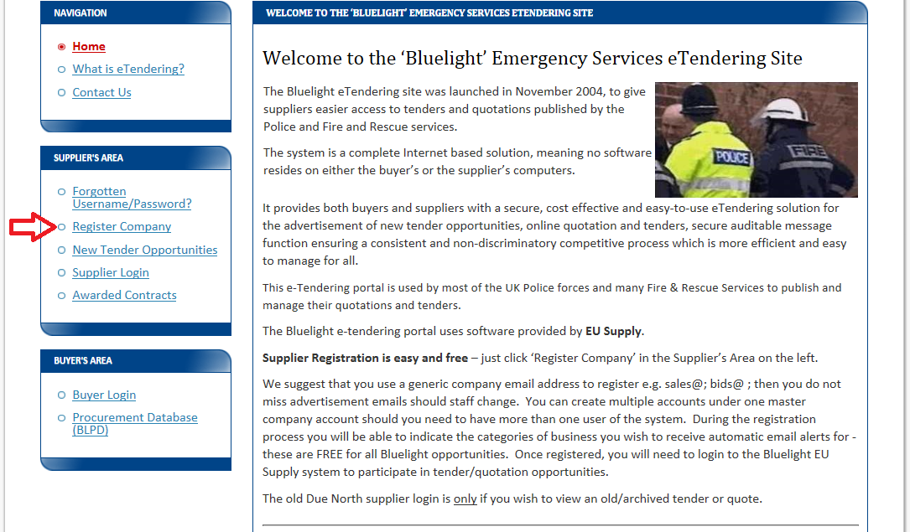

Then click **‘EU Supply – New Supplier Registration’** *(indicated by purple circle in screen shot below)*  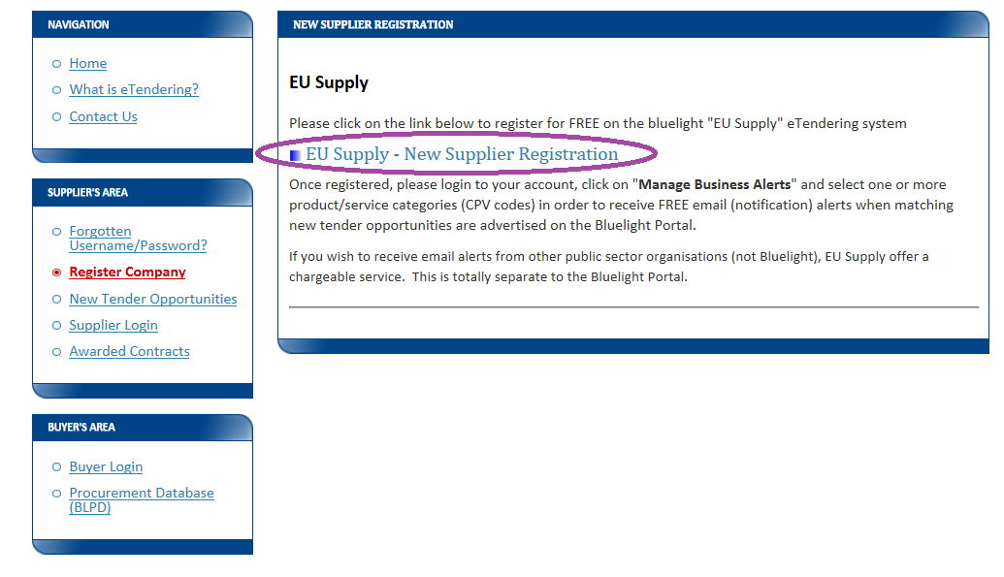

 Complete the onscreen Supplier **Registration Form** and click ‘Save’ *(similar to below screen shot)* 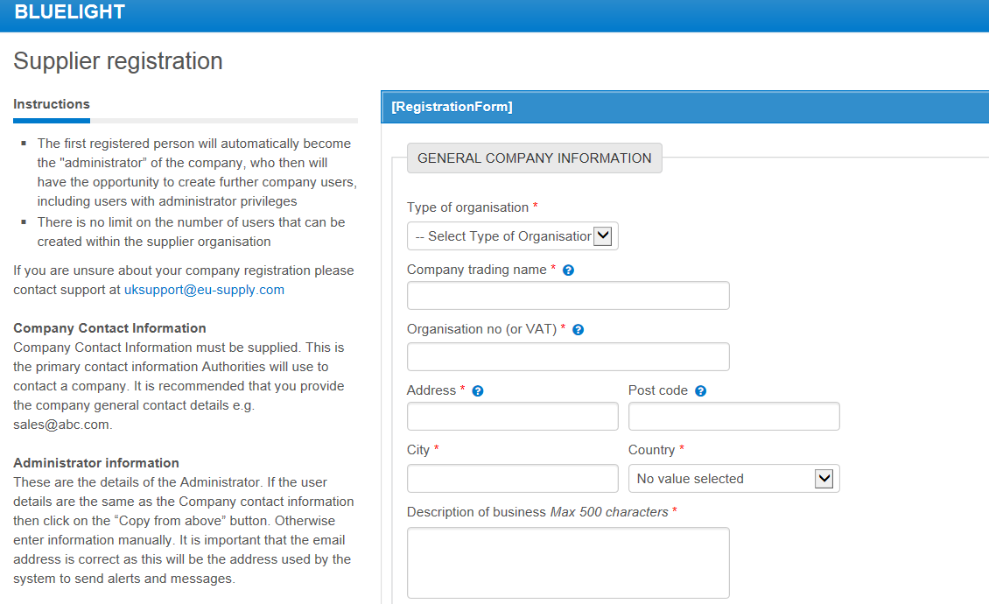 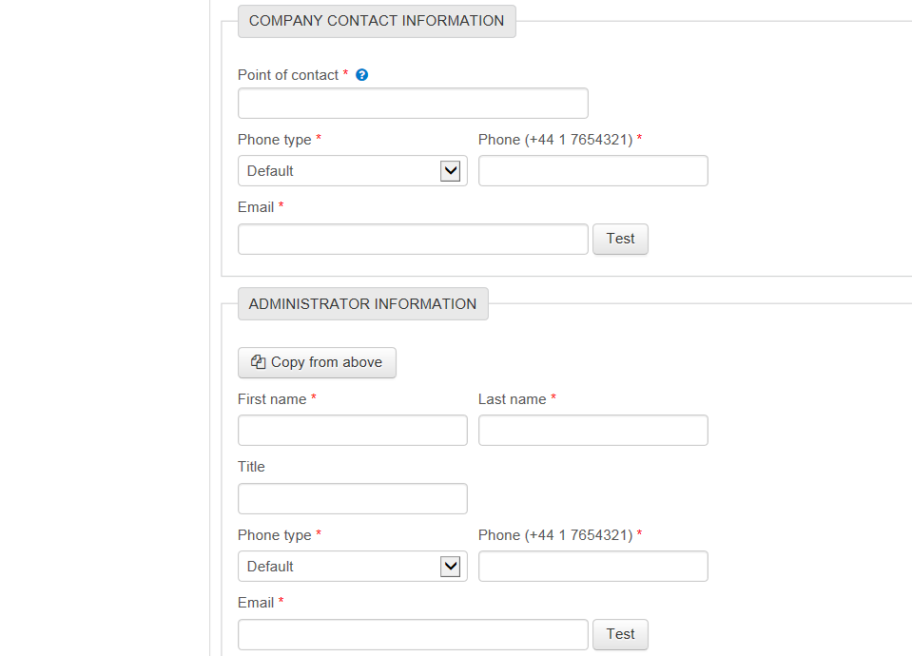 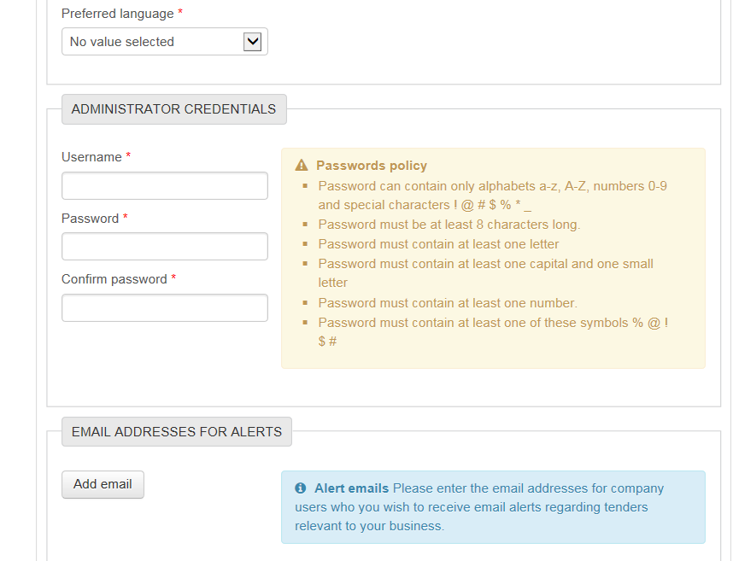 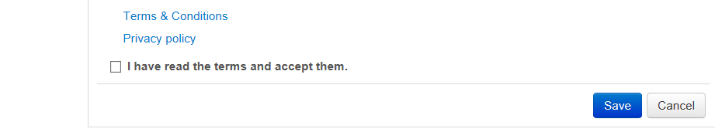

### 2.2 Is registration as a supplier FREE of charge?

Yes – on the bluelight EU Supply portal.

### 2.3 My company does not have an Organisation number, company registration number or VAT number but the on-line Registration form requests one - can we still register?

Complete your registration and input ‘n/a’ or ‘partnership’ or ‘charity’ in the relevant boxes, and submit.

### 2.4 I tried to Register my company, but the EU Supply system advised that we are ALREADY registered. Why can’t we have more than one registration?

If the EU Supply system advises that **your company is already registered** PLEASE DO NOT register again. A supplier company should have a single account – shared with colleagues or with additional users within the same account, if required. Having multiple supplier accounts causes confusion, can waste everyone’s time and can lead to missed tender opportunities, as a Buyer will not know WHICH of several different accounts to send an Invitation to.

### 2.5 Should I have a personal email address or should we use a shared mailbox email address on our company account?

When registering your company, ideally your contact email address should notbe someone’s personal email address. It is better to set up a more ‘generic’ email address – such as [tenders@companyname.co.uk](mailto:tenders@companyname.co.uk)  or [bids@company.com](mailto:bids@company.com) - then password reset emails, notifications, etc. can be accessed when that individual person is on holiday/ away/ has left the company.

3.Logging On

### **3.1 I can’t** remember our login details (User Name or Password). Should I register again?

NO. If you register again, it will lead to multiple accounts which cause confusion, waste everyone’s time and lead to missed tender opportunities.

### 3.2 I have forgotten my User Name and/or Password. How do I ask for a reminder?

If you have forgotten your username and/or password for the EU Supply portal, please go to <https://bluelight.eu-supply.com>

and in the **SUPPLIER’S AREA** on the left click on Forgotten Username/Password?

then under ‘**EU Supply’** heading, select the Forgotten username or password? option

and enter your **email address** - the one the EU-Supply system has registered for your company- and click **OK**. The reminder emails will be sent to that email address. It is best to have a shared email address rather than a personal one, so that when users change, the company account can still be accessed.

### 3.3 I am not receiving emails from the EU Supply system. What can I do to resolve this?

If you are not receiving emails from the EU Supply system it may be that your email firewalls/spam filters have blocked them, and dependent on your spam filter settings they may be in your junk mail box/ spam or have been automatically deleted.

Make sure that your system security /firewalls allow emails from domain name **@eu-supply.com**

### 3.4 I have changed my password but I still can’t log on. What can I do?

If you have recently changed your password, but are still unable to access your EU Supply account, it might be worth DELETING your Internet browsing history, in case your machine has remembered your old password automatically and has not picked up the fact that you have changed passwords recently. Please DELETE your internet browsing history, then log out of all internet sessions (any application that is using the Internet) and then log back in again.

Occasionally, within EU Supply you may receive the below notification: 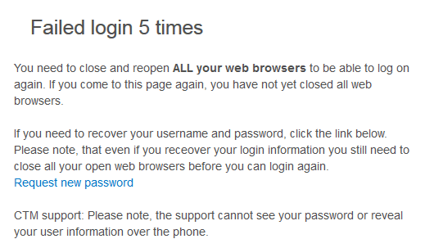

If you are using a Windows computer, there should be a menu option within **Tools** to Delete your internet browsing history.  The most important thing - AFTER you have deleted your history - is to log out of **all** internet sessions for the deletion to take effect, prior to logging back in.

In addition, if you have asked your computer to remember your password each time and auto-populate the login screen, it may be worth suspending this facility, then manually entering the username and password.  You can always get the system to remember this password at a later date once you have been successful in logging in.

4. Managing your Supplier Account

### 4.1 How do I update my Personal contact details?

To amend your personal contact details, e-mail address, username or password

go to <https://bluelight.eu-supply.com>

click on the left hand side **Supplier Login** > and then **EU Supply – Login**

Once logged on, click your name at the top and then click ‘**Edit**’ under ‘User details’.

Edit and **Save**.

### 4.2 How do I update Company details?

To amend your company details, go to <https://bluelight.eu-supply.com>

> on the left hand side **Supplier Login** > and then **EU Supply – Login**

Once logged on, click Administration at the top > and then click “**Company administration**”.

Click ‘**Edit’** for the relevant section e.g. Company information or Supplier Profile

Note: Only users with ‘Company Administrator’ access can amend company details.

### 4.3 I cannot edit my Company’s ‘Organisation number’ – it is greyed out. How can I change it?

You cannot edit this yourself. Please email Bluelight Admin: [BLAdmin@cheshire.pnn.police.uk](mailto:BLAdmin@cheshire.pnn.police.uk)

### 4.4 On our Supplier account, we have one person set up as ‘Company Administrator’ and another as a ‘Company User’. What is the difference between a ‘Company Administrator’ and a ‘Company User’?

The first user to be set up on any Company account must be a Company ADMINISTRATOR. Additional users can be either Company ADMINISTRATOR or Company USER.

A Company ADMINISTRATOR can automatically see and submit all active tender Responses on the account - the ones he HIMSELF expressed interest in and also the ones someone else on the company account expressed interest in.

A **Company USER** can submit a Response to a tender but ONLY if **he** HIMSELF has expressed interest in the tender, or he has been assigned to that tender that someone else from the account expressed interest in. He CANNOT automatically access all ongoing tenders on the account.  
If a Company USER wants to express interest in a new tender and submit a Response, then he can do this on his Company USER account, just like a Company ADMINISTRATOR would.

If a Company ADMINISTRATOR has already expressed interest in a tender, then a Company USER cannot express it again for that same tender. Instead he has to be ‘assigned’ to that specific tender by a Company ADMINISTRATOR, so that the Company USER can access that tender and submit a Response. If a Company USER is expected to respond to any ongoing tenders on the account, a Company ADMINISTRATOR must ASSIGN the Company USER to the teams of these tenders (by going onto the Response page of a tender and clicking on ‘Assign User Access’, then setting the USER as an editor) and then he can access and submit them.

### 4.5 How do we add a new user to an existing supplier company account?

If the user is replacing someone, EDIT the existing user’s details. It is best to regard your supplier company account as a SHARED account and not as a personal account. Simply having a shared email address and sharing logon details is the easiest way to achieve this.

If you really must add an additional user to an existing company account, go to <https://bluelight.eu-supply.com> > on the left hand side **Supplier Login** > and then **EU Supply – Login**

Once logged on, click **Administration** at the top > and then click “**User profiles**”.

Click button “**Create user…”** and fill out the form, allocating the new user with a ‘Security role’ of either “**Company administrator**” or “**Company user**” access.

Note: Only users with ‘Company Administrator’ access can add additional users to their company. See also question re the difference between these roles.

Please also DELETE users if they are no longer required.

### 4.6 I think our Company account might be showing an old email address. How can I check and update contact details and email addresses?

**There are TWO places within the account** where a NAME and email address is stored and you need to check /edit **BOTH** of these places because the Name and/or Email address may be different in the two places.

The first place is:-

      click “**Administration”** on the top blue row

* Click “**User profiles”**
* Click your **name** (person’s name)
* Click **EDIT** button
* and  then **edit the Name and/or** **Email address**
* and **Save**.

The second place is:-

       click “**Administration”** on the top blue row

* Click “**Company administration”**
* at the end of the upper section, click **Edit** button
* Under contact name and/or ‘Email address to contact person’, check this and if required, EDIT it
* and save.

Please follow these steps to check and correct the registered Name and Email addresses for your supplier account.

5. Search for New Tender Opportunity or be Notified of New Opportunities

### 5.1 How do I Search for New Tender Opportunities?

New advertised tender opportunities can be found by going to <https://bluelight.eu-supply.com>

then select "**New Tender Opportunities**" from the ‘Supplier Area’ on the left. **This is BEFORE you log on.**

Then you can either just select “search“ to see all current opportunities advertised by any of the police and fire services using the EU Supply portal OR enter your search criteria (e.g. select the buying organisation from the drop down box, or enter a keyword in the "Contains" box), then click on **Search**.

If you are **already logged in to your account**, then on the ‘Welcome (your name)’ page,

click top left on **Public Quotes/Tenders** and enter your search terms. The search results will be listed underneath.

If you have added one or more CPV categories to your account and have set up your Business Alerts (see below question), you will receive automatic email notifications when new tender opportunities are advertised by any of the authorities using the system under the categories/CPV codes you have selected, negating the need to regularly search for new opportunities that may be of interest to you.

### 5.2 How can I receive free Notifications of New advertised tender opportunities?

EU Supply asks you to set up certain ‘**Category Codes’** (Common Procurement Vocabulary or **CPV codes)** to describe what kinds of business / service you provide.

This is a fundamental part of your management of your supplier account. It is important to set these up on your account because they can impact whether a buyer might select your company to Invite, based on the CPV Codes you have set up.

If you set up these codes on your account and **Manage ‘Business Alerts’,** you will receive free automated emails notifying you of all Advertised new tender opportunities that match your CPV Codes. This will save you from having to search for new tender opportunities on a regular basis.

### 5.3 How do I set up or manage my Business Alerts?

To do this go to <https://bluelight.eu-supply.com> click **Supplier Login** and then EU Supply – Login and enter your username and password.

Once logged on, the “Business Alerts” option can be found under the **Account Administration** area on the left hand side of your Welcome … page.

Business alerts are free and you will also receive email alerts for other EU Supply customers too.

Please note that you will only be automatically notified of an ADVERTISED new tender opportunity - if the tender is being run by INVITATION, only those suppliers who have been sent an Invitation will receive a notification.

**Setting up “Business Alerts” is a 2-part process**

1. firstly you need to select that you want to receive alerts
2. secondly select Category Codes (CPV codes) that match your business

Firstly, the ‘Company Administrator’ of the account clicks ‘**Manage Business Alerts’** – *on the left (circled in red in screen shot below)*

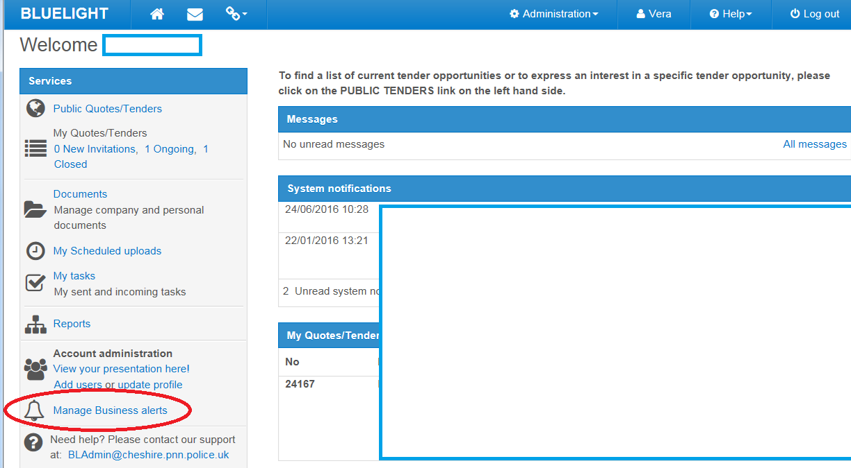

OR you can find this via “**Administration**” on the top blue header

> Company administration > Manage Business alerts > Edit

Then click the button **Start using Business alerts**  *(circled in red in screen shot below)*  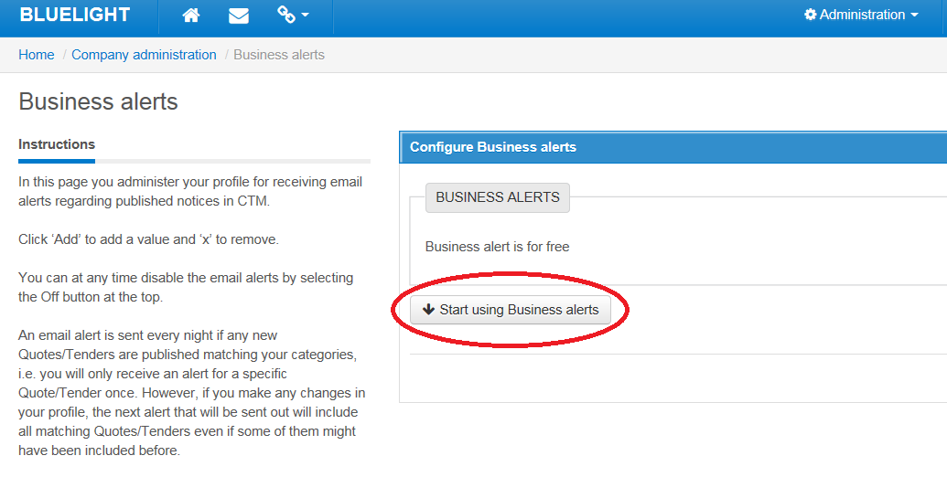

Make sure you have an email address in the box next to **Add email**  and **Save.**

Then click **Next** button. 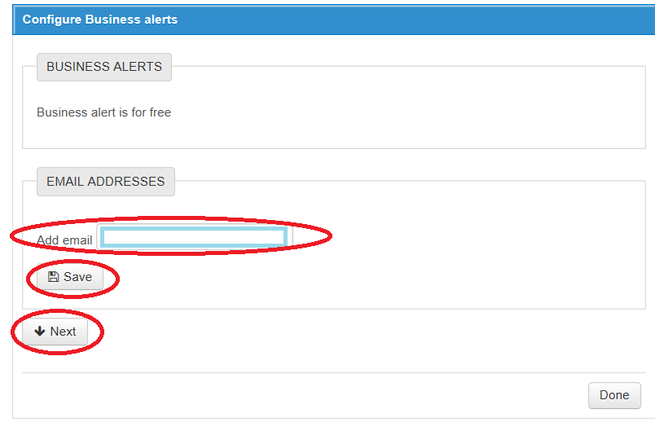

Then click **+ ADD CPV codes**  - to select the Category Codes / CPV codes that match your business, so that you will receive notifications only about new tenders that are relevant to your business.

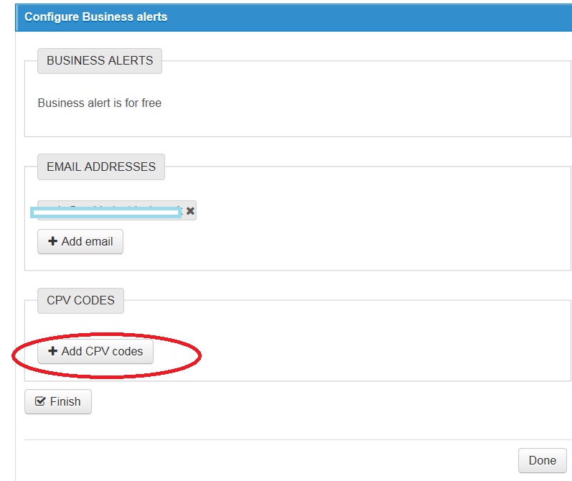

You then need to find and select CPV codes that best match your business - you can either use the **Search** facility or click in the **CPV tree** of codes.

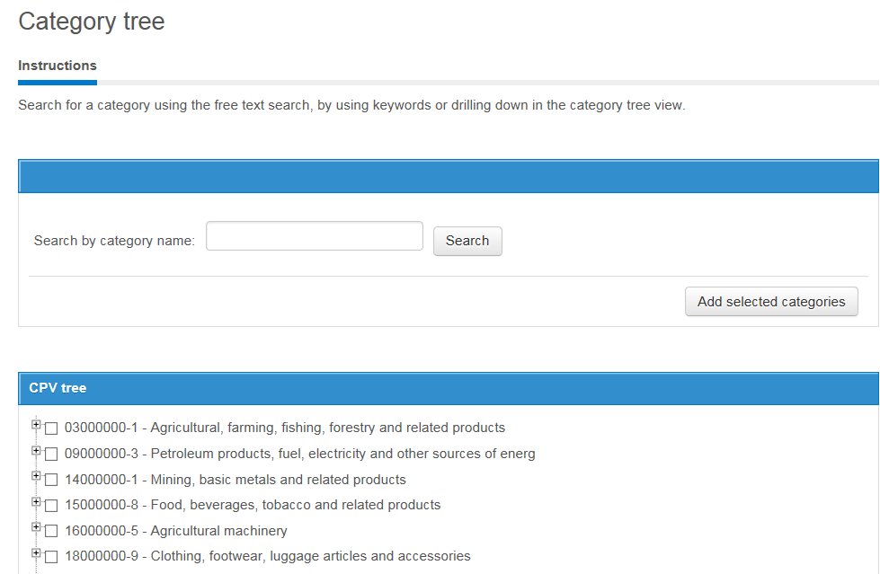

If you **click the + sign** to the left of the code, it reveals lower / more specific codes.

e.g. Agricultural machinery 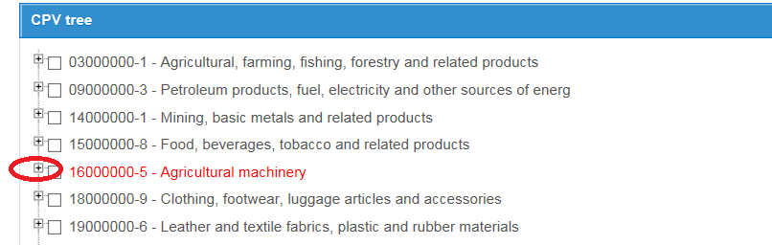

Clicking the **+ sign** then reveals:- 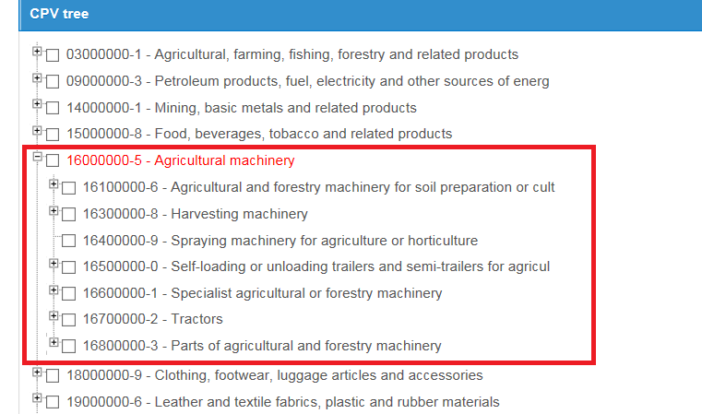

If you really need to be specific, you can again click the **+** sign to the left of the box and see further detailed codes.

When you find the code/s you want, click / **tick the little box** (to show which ones you want to select)

and then click the button **“Add selected categories**” 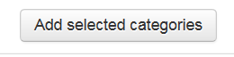

Then click **“Finish**” button and **“Done”** button.

NOTE: If you select a high level code (broad code) and also several lower level codes (more specific) the system will choose just the high level one.

### 5.4 I have searched and cannot find a new tender opportunity. Yet I know that my company is invited. Why can’t I find this new tender?

Some tenders are not advertised/ not published/ not publicly viewable or searchable. This is because the tender is being run via **Invitation**. In this case, a buyer sends Invitations directly to a number of Supplier accounts and you will need to log into a particular INVITED account in order to see and Accept the Invitation.

If you know that your company has been Invited and you are logged into your account and cannot see the Invitation there, then the Invitation has been sent to a different account. This can easily happen when your company has MULTIPLE accounts. Having duplicate/ multiple accounts causes confusion, wastes everyone’s time and leads to missed tender opportunities. Please try to REDUCE the number of different accounts to a MINIMUM.

### 5.5 My company has several accounts. Can they be merged?

No. Supplier accounts cannot be merged. But they can be edited and they can be deleted/ deactivated.

If your company has duplicate/multiple accounts, please confer with your colleagues to decide which accounts can be deactivated. Try to reduce your company accounts to ONE. If your company MUST have several different accounts, try to differentiate them – maybe add a location or a sector after the company name. This will assist a buyer to identify which account of your several separate accounts to send a tender Invitation to.

6. Respond to Tenders

### 6.1 I want to download the tender documents but there are no documents to download/ this option does not work. How can I view or download the tender documents?

You need to FIRST express your interest in the tender – click the big blue **Accept** button - top left on the screen. Then you will be able to view/ download the documents. When you are logged on and IN the particular Tender, within the **My Response** tab - click the option “**Access documents**” *(circled red in screen shot below)* to view and download the documents provided by the buyer.

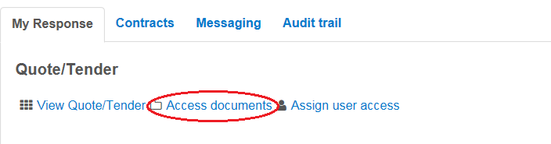

### 6.2 I have accepted a tender opportunity but now realise that we are not interested in this tender. What do I need to do? Can I cancel our interest?

Click the ‘**Cancel expression of interest’** button at the bottom of the tender response page (on the ‘My Response’ tab)



### 6.3 I cancelled our expression of interest but now I want to undo this – we now want to be involved in this tender. Can we do this?

Yes. If you can see the ‘Resume’ button, click this and your interest will be resumed.

### 6.4 I have a question about the tender – a specific question on the commercial / financial / technical aspects of what is required (not about the system). Who do I contact?

You need to contact the Buyer responsible for the particular Tender/Quote and you should do this via the Messaging function within the tender.

### 6.5 What is ‘Messaging’ and how do I use it?

Within each Tender, there is a tab called Messaging. The ‘**Messaging’** function is like an internal email system on the portal - between the Buyer and the Suppliers on THIS particular tender. It keeps all questions and their answers on the Tender and ON the system, so is auditable.

The Buyer can send you a Message and you can send the Buyer a New Message or reply to the Buyer.

**To send a new ‘Message’…**

(1)    Log into your bluelight ‘EU Supply’ supplier account

(2)    then under ‘**My Quotes/Tender’**, click into the particular Tender  - *the blue writing/the title*

(3)    Then **within the tender**, click on the ‘**Messaging**’ tab

 - *circled in green in the example screen shot below*

       – and to create a “New Message”,  click on “**New message**…“ button

      >  then type in your question

       >  you do not need to choose a Recipient as it will ONLY go to the Buyer

       >  then **Send**

      – it will go directly to the Buyer, who will then answer – ALSO within the Tender, so you need to go into the Tender later to see what the answer is.

Example screen shot:-

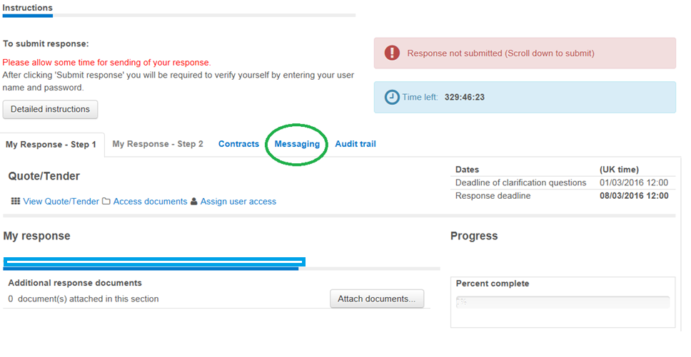

A Message is **bold** type has NOT been read by you

A Message shaded in pink has not yet been sent by you – it is still in DRAFT status.

### 6.6 Can I submit a quotation or tender response more than once? I have already submitted my tender Response but I want to add something.

As long as the ‘Submit response’ button is still blue, you can still submit a Response 

If this button is greyed out, you are locked out of the tender and cannot submit a Response.

You can submit a quotation /tender response as many times as you want, until the ETQ (End Time Quotation) has timed out – i.e. until the response deadline is reached. Later submissions will overwrite earlier ones, so the Buyer will only see your latest submission /last Response submission. The Buyer cannot see your Response submission until the ETQ has timed out. It is better to submit early and update information, rather than leave the whole submission until the last minute.

**Do not click the “Withdraw response” button** *(indicated with red circle below).* This button is misleading – it does NOT withdraw the already-submitted response but **withdraws the supplier completely from the tender.** If a Supplier clicks “Withdraw response” it means that they are no longer able to participate in this tender – they have removed themselves from it.

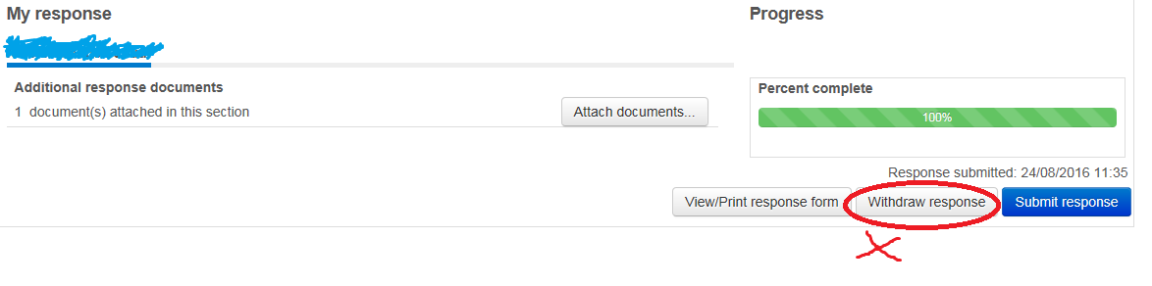

### 6.7 How do I send a screen shot (screen dump) via email?

If you want to illustrate what you are seeing on your screen (such as an error or warning), you might want to send a Screen shot (screen dump).

To take the screen shot, click on the relevant screen and click the ‘Alt’ key and the ‘Print Screen’ key. This copies the screen. Then to paste the screen copy – into an email or a Word document - open the correct place in the email or Word document and press the keys ‘Ctrl’ & ‘V’. This pastes the image into the email or document.

### **6.8 On the tender, it shows** ‘Time left’. **What does this mean?**

The ‘Time left‘ is a Live countdown of how much time you have left until the Response deadline.

For example:- 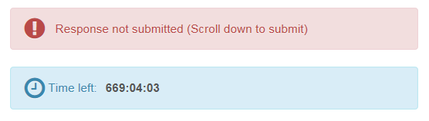

In the above example, the time left is 669:04:03. This is 669 Hours, and 4 Minutes and 3 seconds.

**Allow PLENTY of time for uploading and submitting your response.**

**At the end of your response you will be asked to CONFIRM your User Name and Password so have them handy and allow time to confirm them**.

It is an electronic deadline so you will be locked out of the tender before you have finished if you do not allow sufficient time. Do not start to upload your attachments just a few minutes before the response deadline - you will be timed out and your efforts will have been for nothing. Allow PLENTY of time. **Late responses are NOT accepted.**

### **6.9 I have attached documents in my tender Response, i.e. uploaded the compulsory documents, BUT the system still shows** “1 Question unanswered”. **The system does not seem to recognise that I have attached the required document.  What do I need to do to answer the question and convince the system that I have 100% completed it?**

If you have a "free text box" within the question as well, in order to get the question 100% answered, a supplier needs to ALSO type something into this blank free text box (as well as uploading the file/adding the required attachment).

You need to BOTH **type something** into the blank “free text box” **AND upload** your attachment. Otherwise the system won't understand that you HAVE 100% answered that question.

Example: Official Secrets Act question:-  
Supplier has attached the required file (this part is OK) but the "free text box" is still empty. You can just type there **"File attached"** or **"Document added"** and Save.   
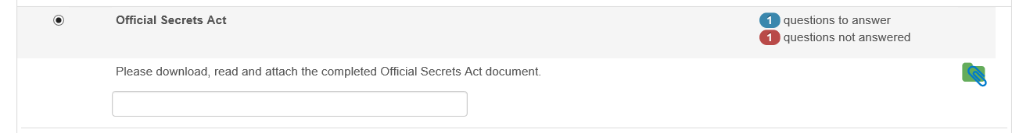

.. Bluelight .. Bluelight .. Bluelight ..Bluelight.. Bluelight.. Bluelight.. Bluelight ..Bluelight..